A Glimpse On


An NGO for pledge to progress

Regd. No: Bogra-436/93 dt. 29.04.1993

‘Nashim-aloy’
College Bottola, Fulbari, Bogra
BANGLADESH
Phone: 88 051 64766, 88 051 67766
88 02 8125487
E-mail: bogfound@bttb.net.bd

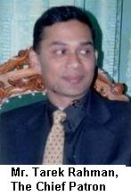
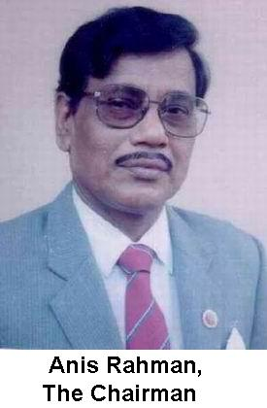
Bogra Foundation
-an NGO for pledge to progress

Background

Bogra is a district where Buddhists, Hindus and Muslim cultures enriched its historical importance. But with passes of time the rural people of Bogra district (area 2929.91 sq km and population 3.20 million) in the northern zone of Bangladesh has become now backward with respect particularly to education, employment, medicare, clean water, sanitation, communication, environment and women’s human rights. About 65% of the population constituting the rural poor who are victims of hunger, disease and oppression, have very little access to the benefits of meager development activities. There is also severe inadequacy of agencies, funds, uplift and leadership so necessary to ensure economic program and social dignity to the rural poor, especially women, girls and children. The above are some of the empiric factors which led to setting up of Bogra Foundation on 21-02-1992 by some dedicated social workers under the leadership of a dynamic social worker Mr. Anis Rahman – an ex-civil servant of the Government.

Objects and Legal Status

The objects of Bogra Foundation (BF) are to (a) end illiteracy, hunger, disease, deprivation and repression on women and girls in society (b) capacitate the rural poor, especially the women, to undertake self-management of their development activities with respect to education, employment, medicare and disease prevention, road-communication, environment conservation, human rights, legal aid etc (c) rebuild the economy on social justice and (d) facilitate the poor citizens to lead self-determined life with dignity in society. As a voluntary nonprofit social welfare and humanitarian organization, Bogra Foundation was registered under number Bogra-436/93 of 29-04-1993 by the Social Service Department of the Government of Bangladesh.

Management Structure

The management structure of Bogra Foundation consists of at present a General Body of 103 members, an elected Executive Committee of 11 social workers, an Advisory Council of five local experts, a body of five patrons and a Legal Aid Cell of seven members headed by a judge-court advocate Ms. Choudhury Rawshan Jahan.

Accomplishment and Ongoing Programs

Since inception in 1992, Bogra Foundation has been carrying out multifarious programs for self-sustaining welfare of the rural poor and non-privileged communities of Bogra district (area 2919.91 sq km and population 3.2 million). The following are of its accomplishments and ongoing programs.

- Medicare, MCH and Family Planning: Through a Free Friday Clinic run with the assistance of Dr. Azizur Rahman and Dr. Nurunnahar Rozy, Bogra Foundation provided free medicare (prescription with medicine in some cases) to about 36,000 poor patients including cases of anti/post-natal care, safe delivery, adoption of family planning methods and surgical operation of acute diseases. By organizing eye camps in different parts of the district 8500 patients were medically treated, 572 cataract operations were conducted and spectacles were given to poor patients free of cost. About 27,000 fertile couples have also been motivated and served with contraceptives for adoption of family planning.

- Clean Water Supply and Sanitation: For growth of hygienic living environment, 25 hand tube-wells were installed for use of about 250 poor families and 60 sanitary pit latrines were given to educational institutions. A drive is run for use of arsenic-free water in the rural areas.

- Bio-diversity/Environment Conservation: BF has organized about 30 public meetings to conserve bio-diversity/environment. Moreover around 50,000 saplings have been planted and are nourished in homestead gardens, road and riversides and in vacant/fallow lands for expansion of social afforestation. It is note-worthy that Bogra district is environmentally most vulnerable in the sense that the area of forests and trees in this district is only 04% against 09% in the country.

- Leadership-building on Human Rights: Over the last few years 14 seminars, conferences and workshops (of about 950 rural social workers) have been organized to build leadership among them with respect to advocacy, good governance, gender equity and stopping of human rights violations (on women and girls) and child labour abuse.

- Spread of Education: In order to raise efficacy of education system for spread of mass literacy, BF has assisted about 110 schools in the shape of maintenance costs, construction-cost of building, supply of books and sport materials and development libraries and reading-rooms.

- With the objects to eradicate and punish human right violations, Bogra Foundation runs a Legal Aid Cell (under guidance of its secretary-general Advocate Choudhury Rawshan Jahan), provided funding support and legal advice and has settled the cases of 310 woman/girl-victims of human right violations and rehabilitated 21 woman/girl-victims with self-employment.

- Development of Rural Communication: For development of rural communication network, Bogra Foundation has assisted in construction (with the collaboration of LGED of the Government) of about ten local roads of Bogra district and is going ahead with other road construction programs in the area.

- Relief Operation: Since natural disasters occur very frequently in this district, BF has collected funds and materials from the local agencies and well-to-do people and so far distributed succour viz clothes, food, medicine, house-building materials etc worth about Taka 250,000 among nearly 2,000 disaster-stricken families. Also it donated a handsome amount to Prime Minister’s Relief Fund recently on 21.01.2003 to save the cool-stricken people this year in northern zone of the country.

It may be mentioned that BF has a network of 12 union committees (having membership of 6,100 volunteers) and 230 village-based target groups (of 4,600 poor women) which hold periodic meetings in their respective areas and undertake planning, execution, management, evaluation and follow-up of various collective development activities.

Some activities pictures of Bogra Foundation are shown below :

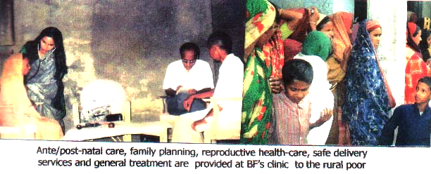

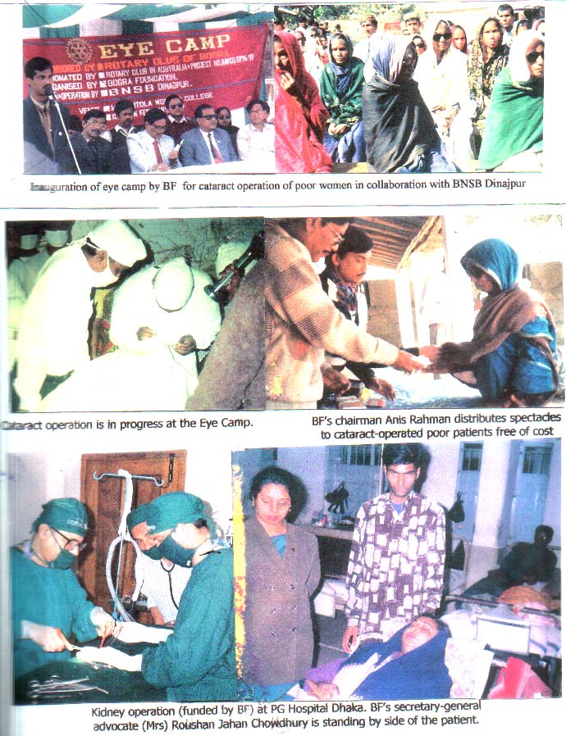

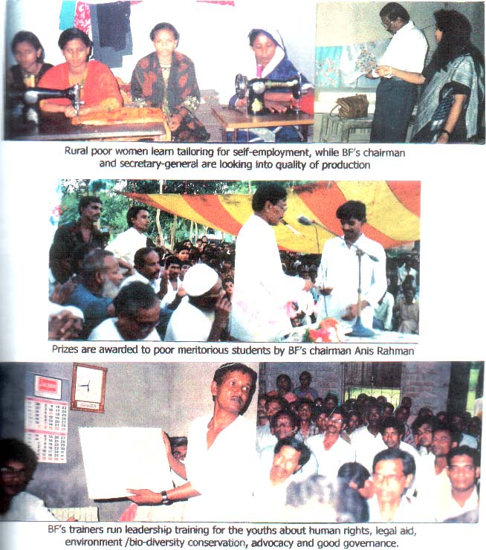

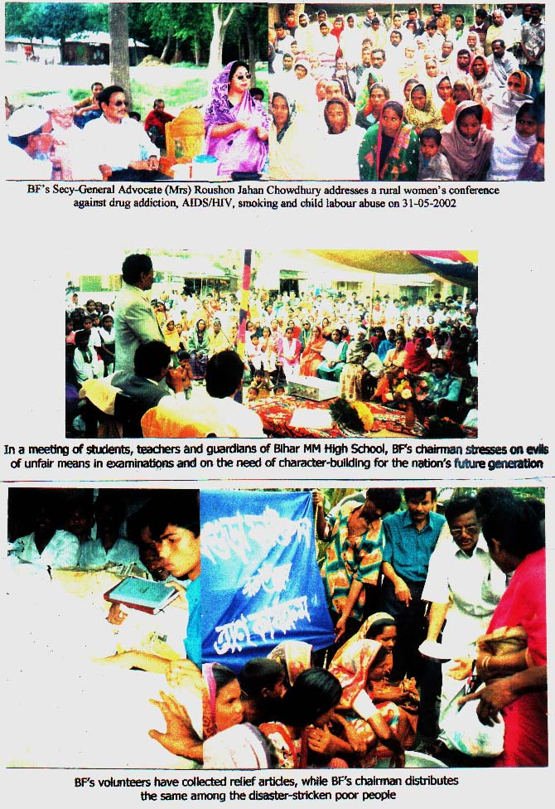

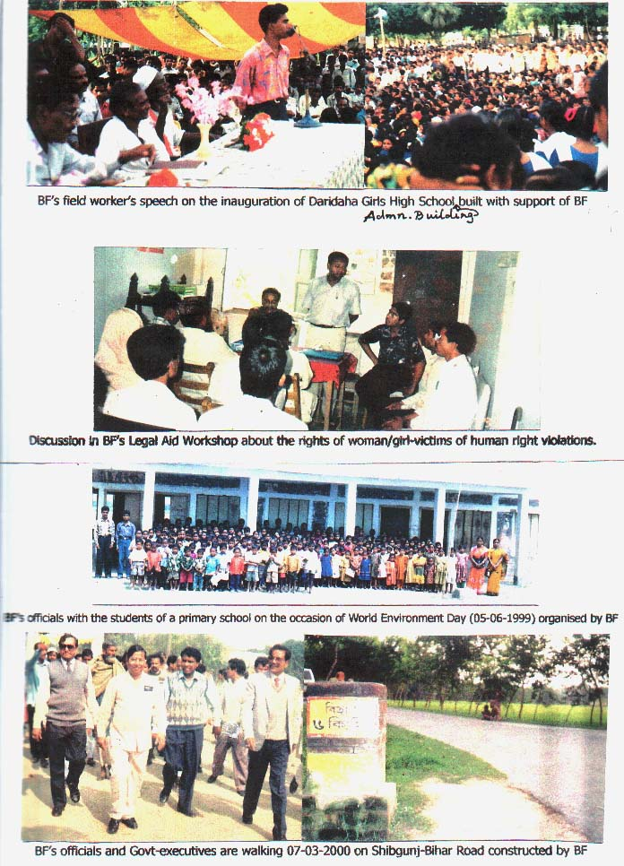

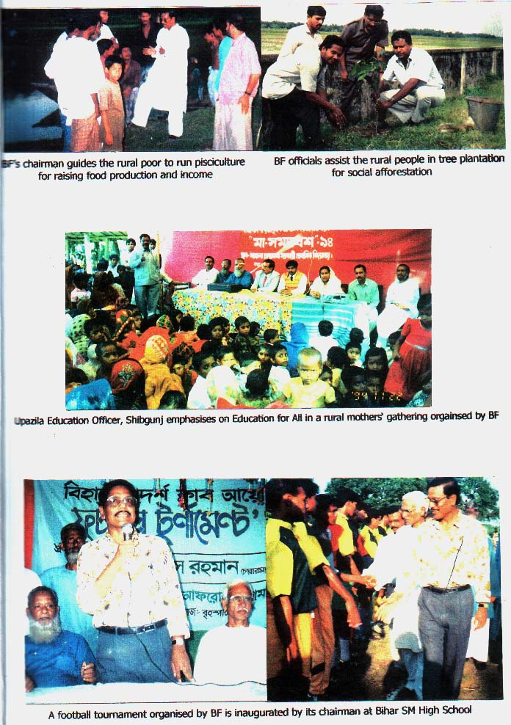

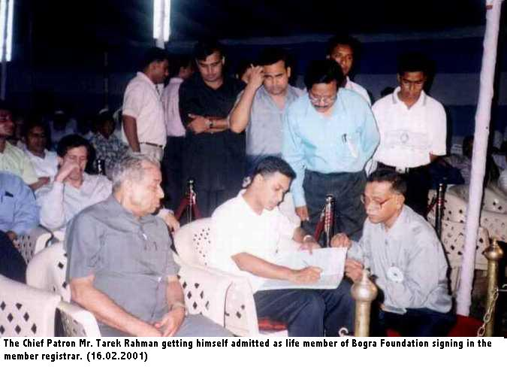

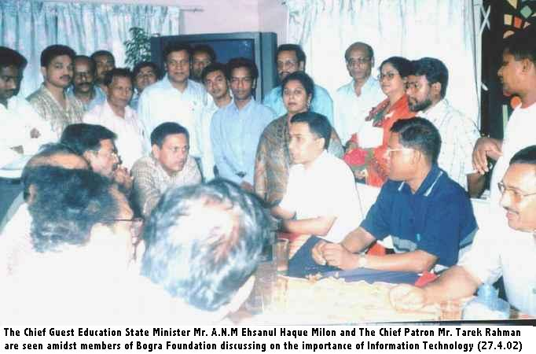

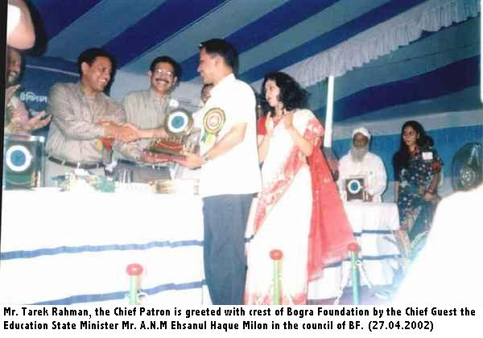

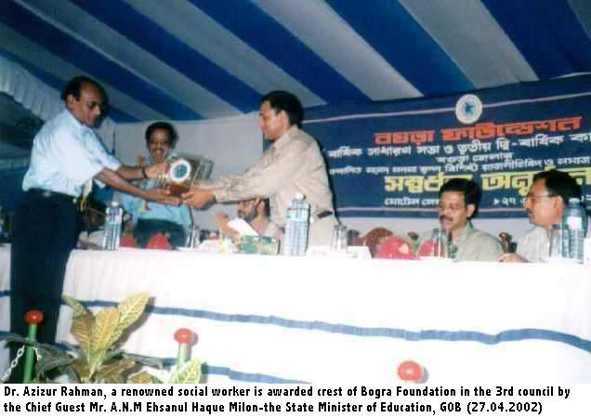

Appeal to Donors and Emigrant Bangladeshis for Funding of Future Plans

In view of the growing public participation in, and benefits derived from, the past accomplishments and in response to the long-felt needs of the rural poor, Bogra Foundation is working for implementing a number of projects for (a) establishment of shelters for the distressed women and children (b) setting up of a cancer hospital (c) growth of literacy, micro-trade skill and self-employment for poverty alleviation (d) broad-basing of health-care, sanitation and family planning activities (e) advocacy, good governance, gender equity and human rights programs (f) conservation of bio-diversity and environment and (g) enhancement of the rights and interests of the poor orphans, the helpless aged, the handicapped and the disadvantaged tribals living in the district.

So far, the activities of Bogra Foundation were funded by the organizing members specially Chairman, some local elites/agencies & well-to-do persons. We did not obtain funds from any foreign or international donor agencies.

We fervently request the Government agencies, big NGOs, foreign/local donors emigrant benevolent Bangladeshis and international funding organizations to collaborate with our efforts for service to the distressed humanity of this historical part of Bangladesh.

It may not be out of place to mention here that His Excellency the President of the Republic and Hon’ble Prime Minister of the Government of Bangladesh kindly appreciated our activities recorded in our council-souvenir. The Chief Patron Mr. Tarek Rahman is always helping the organization with his moral support and assistance. Well-to-do people of Bogra living within and outside the country are urged to come forward to help Bogra Foundation to implement its humanitarian program.

Contact Person

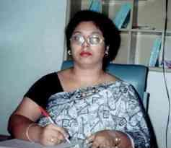

Choudhury Rawshan Jahan, Advocate

Secretary-General
‘Nashim-aloy’, College Bottola
Fulbari, Bogra, Bangladesh
Phone: 88051-67766, 88051-67766
8802-8125487
E-mail: bogfound@bttb.net.bd

